This document describes how to work with the StAugustine and the StAugustineServices folders in test (SobekCM 4.10) and is not intended to replace the full install documentation that already exists. Also this documentation assumes the existence of the testufdcimages site. This site as well as both services and other important information are referenced in the StAugustine\Javascripts\VTkeys.js file. Finally the test database is referenced in the DPantherRESTServices and the dpRestService web.config files.

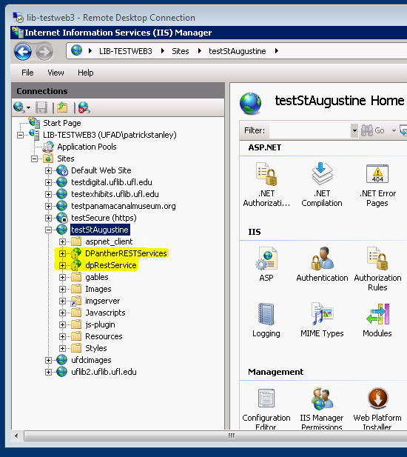

The testStAugustine site is created after copying StAugustine and the StAugustineServices folders into the inetpub\wwwroot directory with the following basic settings.

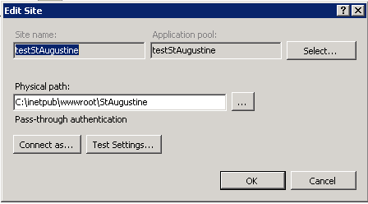

After the site is created you need to create the two highlighted services with the following basic settings.

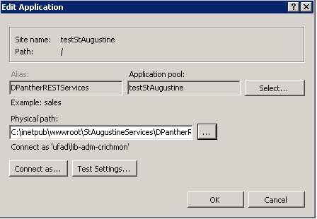

The physical path here is C:\inetpub\wwwroot\StAugustineServices\DPantherRESTServices

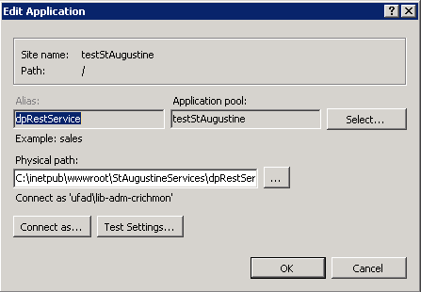

The physical path here is C:\inetpub\wwwroot\StAugustineServices\dpRestService